Theology of Prayer and Practice
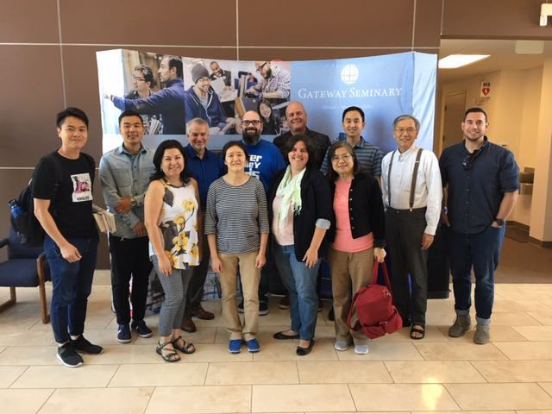

Theology of Prayer and Practice (Dr. John Lai)

Videos for teaching Dr. John Lai L221781 Prayer: Theology and Practice

First Session (I)

1. Why do we need to Pray?

2. Why is prayer so difficult:

3. The Lord’s Prayer:

4. Abraham’s Plead for Sodom:

5. David’s Confession:

6. My Prayer Life Journey:

7. Fasting and Prayer:

8. Pray in the Spirit:

Second Session (II)

9. Jesus’ Prayer in Gethsemane:

10. Pray without Ceasing:

11. How to Build Up a Prayer Leader:

12. Lectio Divina:

13. How to win a Spiritual Battle:

14. Paul’s Prayer for the Ephesians:

15. Paul’s Prayer for the Colossians:

16. Prayer and the Holy Spirit:

Third session (III)

17. Pray then Preach:

18. Waiting Upon God:

19. A Praying Small Group:

20. A praying church:

21. United Prayer Movement:

22. Watch and Pray:

23. Pray for his presence:

24. The Prayer Life of Jesus Christ:

